Making Accessibility Word Processor Documents

Revised: May 2019

Contents

I. Accessibility Considerations 3
A. Styles and Layout 3
B. Alternate Text for Images: 3
B. Making Links Accessible 4
C. Tables 5
Table Summaries 5
Complex Tables 6
Table Headers: 6
D. Color and Contrast 6
E. Math Content 7
F. Patterned Backgrounds 7
G. Accessibility Checkers 8
II. Conclusion 10
III. Resources: 10

Accessibility Considerations

A. Styles and Layout
Word documents can be structured with styles and layout tools to make the document accessible for users with disabilities.
Layouts: Avoid using tabs, tables or text blocks to layout paragraphs or text. Use the built-in layout features instead – such as the multi-column format option. Also ensure that all objects are structured in an inline format.
Styles: Use headings from the Home Tab (Styles Group). Headings should follow a hierarchical structure (i.e. Heading 1, Heading 2, Heading 3, etc.).
Use lists and bullets from the Home Tab (Paragraph Group). This will ensure that screen readers can interpret the correct list structure.

B. Alternate Text for Images:
All images, tables and objects need to have alternate text applied so the purpose being communicated is conveyed to users of assistive technology. Consider the following when creating alternate text:
- The textual descriptions need to be short and concise while still being meaningful and informative.
- The alternate text should stand alone and act as an equivalent for the image if the image were removed.
- Text should not include the words “figure”, “picture”, or “image” unless it is significant to point out a particular type of image such as a photograph or painting.
- For simple tables, the alternate text can be the same as the table title. For complex tables, the alternate text should describe the general layout of the table.
If an image is decorative or described elsewhere, an empty space should be entered into the alternate text description field.

To add alternate text:
- Select the image
- Activate the context menu or press SHIFT+F10
- Select “Format Picture” and the “Format Picture” dialog should appear
- Select the Alt Text tab from the options on the left
- Enter appropriate alternate text for the image in the Description field. Note: Do not place alternate text in the Title field. The Title field is not read by screen readers.

B. Making Links Accessible
Providing meaningful link text is important when creating links. The text needs to describe the content behind the link or the action that will occur by activating the link. Generic terms − such as “click here” or “read more” − do not provide adequate information on where the link will lead the user and should be avoided. In addition, “click here” implies users are using a mouse.
Generally, when a link is added to a document the link is given a different color than the text. Visually the color distinction allows users to understand that they should explore this text to see if they can act upon it. Users of assistive technology need the links to be labeled as “link” when they are inserted so that users know they can interact with the item. The label of link is provided by default when the hyperlink tools on the toolbar are used in Word. When links are properly added in this fashion, users will be able to tab to the links and activate them with the keyboard, in addition to clicking them with a mouse.

Process to create an accessible link:
Option 1: Type the link address and press spacebar;
Option 2: Select Hyperlink from the Insert tab, Links group. Also select the “ScreenTip” button and add a screen reader only ScreenTip.

C. Tables
Data tables should be formatted utilizing built-in table features of Word. They must also show relationships between header cells and data cells. A header cell is the title of the row or column. A data cell is the meaningful content related to the header cell. Finally, data from multiple rows should not be combined in one row as assistive technology users will be unable to identify what the data is associated with.

Table Summaries
Captions can be used to add table summaries which can be helpful in describing the purpose of a table. A summary of the table can be a description in surrounding text or near the table. For complex tables, it can benefit the user to have a brief description to identify the purpose of the table. However, for simple tables this is not required.

Avoid Embedded Tables
Embedded contents in a Word document are not accessible to users of assistive technology and should be avoided. For example, an embedded Excel file with a table will not be keyboard accessible to users of screen reading software and only the file name will be read.

Complex Tables
Complex tables in Word can be extremely challenging to navigate for screen reader users. If you have complex tables, consider converting the document to a PDF or giving users access to the source files.

Table Headers
There is no way to set a <TH> (table header) in Word. However, you can set “Repeat as header on top of each page”. You can also set the header row in the Table Style Options.

D. Color and Contrast
If color alone is used to convey information, people who are visually impaired or colorblind will not have access to this information. In addition, if insufficient contrast is used, people who cannot differentiate between certain color combinations or have some other visual impairment may have difficulty navigating or interpreting content that depends on the ability to identify color contrast differences.

Recommendation: Ensure that color contrast meets the WCAG 2.0 Level A and AA guideline which is 4.5:1 for standard text and 3:1 for large text (14 point bold or 18 point or above text). Note: You can test the color contrast of your documents with the Colour Contrast Analyser (https://www.paciellogroup.com/resources/contrastanalyser/).

E. Math Content
The best practice is to enter equations using MathType. Note: Screen readers users may still have to take additional steps to access the math content. Ensure that documents are saved in the DOCX format in order to render MathType accessibly.

F. Patterned Backgrounds
Avoid using patterned backgrounds and watermarks as these can interfere with the contrast of the documents and obscure text. In addition, the watermarks are not accessible to screen reader users.

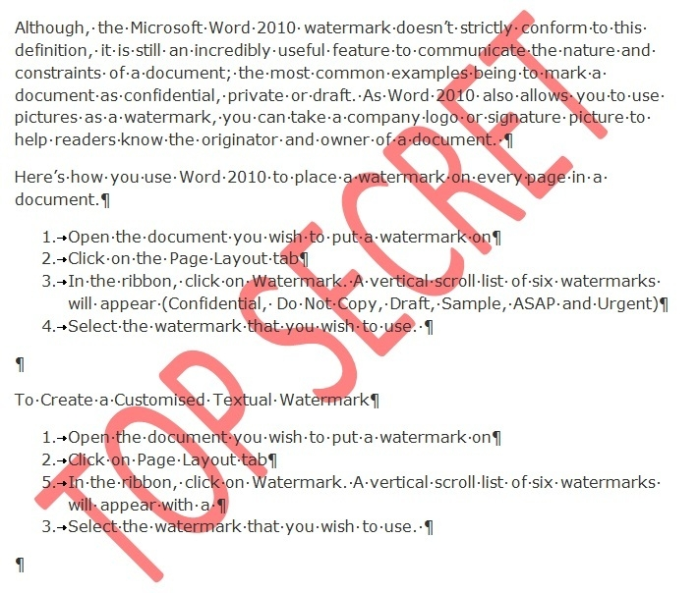
Figure 2: Sample document with watermark

G. Accessibility Checkers
MS Word has an accessibility checker available to help you ensure your files are accessible. The Accessibility Checker can be accessed from the File menu under the Info option: File>Info>Check for Issues>Check Accessibility. The accessibility checker will prompt you through the process of correcting most of the accessibility issues in the document as well as provide instructions. This includes remove repeated blank characters if present. Note: The accessibility checkers are not able to test for color and other considerations that need to be manually tested.

Conclusion
Creating an accessible Word document is readily achievable by following the guidelines above. It is also always a great idea to have a screen reader user test your document for accessibility to ensure that the document if fully accessible.

Due to the accessibility limitations, it is recommended that documents with complex tables be converted to a more accessible format such as HTML or PDF where additional accessibility settings can be made.

Resources:
The following is an excellent resource from Microsoft on Creating Accessible Word documents:
Creating Accessible Word Documents

