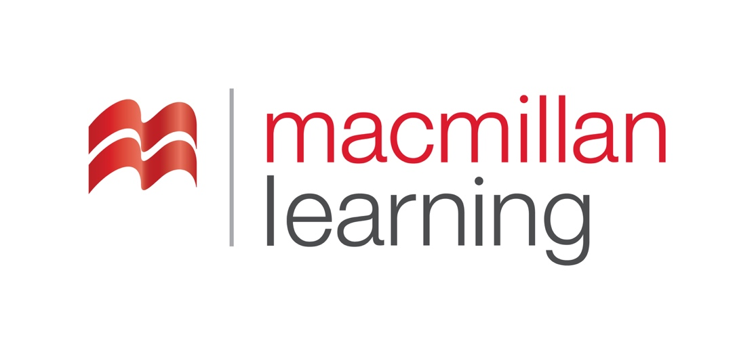

Alt Text Basics
Revised: April 2022

Table of Contents
Alt Text Basics 3
Introduction 3
What is alternative text? 3
How is Alt Text Different from a Photo Caption? 3
Types of Images 3
Supplemental Images 3
Informative Images 4
Images of Text 4
Images that are links 5
Decorative and Hidden Images 5
Tips for Effective Alt Text 6
Additional Resources 7

Alt Text Basics

Introduction
Whole books have been written on the subject of good "text equivalents" for images. Here, we'll provide guidance and examples. You should dig more deeply into the subject if the content you are writing calls for more knowledge.

What is alternative text?
The straightforward way to provide a description of an image on a web page to a user who cannot see it is via the alternative text, also referred to as "alt-text" or "alt tag." This is an HTML term that has been brought into common usage, and we call a lot of things alt text that may actually be delivered another way.

In general, most images within your content will need alt text. These are some of the considerations for starting alt text:
- What is the purpose of the image?
- What is the image intended to convey?
- To what extent is the image described in the surrounding text or to what extent is the image redundant to the surrounding text?
- What level of language is used in the context in which the image is placed?
- What level of detail do I need to use in order to convey the intended message of the image?

How is Alt Text Different from a Photo Caption?
Captions are placed near the image, and often, probably almost always, assume the reader is looking at the photo. They often include no information about the details of the depiction itself, instead they may include when and where the photo was taken. Alt text describes the content of the image. Alt text is used to provide the equivalent of the content or purpose of the image to someone who does not see the image-- someone who is blind, has low vision, or has difficulty processing visual information. Alt text is also used by people on devices that do not support the display of images, and by search engines, which index the alt text as page content.

Types of Images

Supplemental Images
These are images that are not intrinsically part of the content. They may set a tone or a general category of information. Diagrams and illustrations of the subject matter of the text are rarely in this category.

Perhaps the table of contents page for an education course has a photo of children in a classroom. You determine that the purpose of the image is to indicate that this section is on the topic of education in the primary school setting, and the image is further intended to add a friendly and welcoming tone.

Your description, then, should mention the classroom setting, mention the approximate age of the children (sufficient to set them in primary school, and not in college, say) and use language that conveys a welcoming and friendly tone. Excessive detail should be avoided. If the children are looking at a globe, this could be a friendly detail.

An appropriate description in this situation might be:
A class of second-graders smile and laugh as they gather around a large globe in a classroom.

If this same photo were used in an article about the city, or the cafe, or the brand of coffee they are drinking, some of those details would be appropriate. In this context, an effective description is:
A photo shows two women in a cafe drinking coffee and laughing.

Informative Images
The category of informative images includes photos or diagrams of cell components in a biology book, molecular diagrams in a chemistry course, statistical charts in a sociology or statistics book, etc. These descriptions should be written by the author of the text, or, if not available, another subject matter expert. These descriptions need to take into account the pedagogical purpose of the image, and include the specific details relevant to the instructional purpose in this context.

These descriptions often are much lengthier than is workable in alt text. If this is the case, use alt text that conveys the most essential information, and provide a clearly labeled link to the full description, also known as extended or long alt text.

Having a full description on a separate page or displayed separately in another way, allows you to include formatting, special characters, and a length of narrative that alt text doesn't support.

Special characters include things such as Greek characters in math text, inverted question marks, or generally anything outside letters, numbers, and basic literary punctuation marks.

Formatting is not supported by alt text, so if you need to italicize a book title or place data in a table, this content needs to be displayed in a full description.

Images of Text
The first rule is: Don't use images of text. If the item you have is words, using text is much more readable for everyone, and is much more flexible for use with computers, cell phones, smart speakers, braille displays, and all the places the text will be used.
Screen readers cannot read text when it is embedded in an image. Users of other assistive technology may also have difficulty accessing text when it is embedded in an image. Additionally, any layout information is lost to screen-reader users.

Sometimes, though, you need to include an image of text. Perhaps you have a photo of a sign outside a restaurant in 1941, a handwritten note important in history, or an image of a chemical bottle, including the safety label. In that case, along with the description, include all the relevant text.

Images that are links
An image that is a link should convey the destination of the link. You may want to include other information, in some cases.

Simple example: an image of a letter takes users to the Contact Us page-- label the image and link "Contact Us."

Decorative and Hidden Images
Some images are purely decorative. Use this determination with caution-- Here are considerations before you decide if an image is decorative or supplemental:
- What do I lose, if anything, if I remove the image or put a blank square in its place?
- Is the image already completely addressed in the text?

Sometimes images are included in order to break up a large amount of text, to create shorter lines, or to make a page look less daunting to the reader. Those images, if they truly convey no information, and don't set a tone that will be lost by their removal, might really be decorative.

If you are not sure whether the image conveys something, and feel that the page loses something with the image's removal, it should probably be treated as a simple image, and be given a description that gives the basics and sets the tone.

Sometimes images are far from decorative-- they may even be essential to the content -- but the detailed description of them is already contained in the surrounding text. If the full description, complete enough for the understanding of someone who does not see the image, is included in the text, such an image can be treated as decorative, even if it is not technically decorative.

An image can be marked so that it is skipped by the screen reader by giving it alt text of just a space, " ". in HTML, this shows up as
alt=" "

The tool you are using may not show you the HTML. If you are trying to have the screen reader skip your decorative image, put a Space where the alt text should go.

Tips for Effective Alt Text
Basic principles that apply to writing most, if not all, ALT Text for visual elements, include:
- Understand the concept of the visual element. Only when you understand the purpose of the visual element can you accurately describe it with ALT Text. Alternately, you may realize that the image is purely decorative and thus doesn’t need alt text at all.
- Be concise. Keep the ALT Text as short as possible while still imparting a valid text alternative. Using a screen reader is time-consuming, and unnecessarily long descriptions can create a burden on the user. Keep in mind that even an image rich in visual details can be light on key concepts, meaning that a brief description may be sufficient.
- Be clear. Make descriptions clear and easy to read. Information should be presented in a logical and consistent order. Keep the language consistent with the level and tone of the context -- a course for junior high readers and a course for students of advanced chemistry will likely use different vocabulary and grammar.
- Focus on the data. When writing text alternatives with data, focus on the data that’s included in the visual element. Read the surrounding text to ensure that your ALT Text doesn’t repeat anything unnecessarily. Be careful to avoid any description of extraneous elements or information that’s not pertinent to understanding the concept of the visual. Whenever possible, provide clearly formatted text, lists, and tables to clearly organize complicated information or data. This is particularly important with STEM topics.
- Use drill-down organization. Start your description with a brief, general summary followed by an extended description and any pertinent data.
- Identify the type of visual element. Within the text alternative, be sure to mention whether the visual element is a photograph, graph, cartoon, microscope magnification, map, etc. Generic terms like “Image of…” or “graphic of…” are not helpful and Assistive Technology usually already says “Image” when it encounters an image.
- Use proper grammar and language. As with any writing, use correct and easily understandable grammar. Use the same level of language that is used within the main body of text. Use terminology consistent with the context, ie ‘an enlarged view of a chromatid.’ Use the same term as is used in the text, not a synonym.
- Be aware of “new” items vs. those already mentioned. Avoid using indefinite articles (a/an) or nonspecific adjectives (a few, three) with unknown nouns (e.g., “the square is next to...”). Do not use definite articles (the), pronouns (he, she, it), or possessive adjectives (his, hers, etc.) until after an item has been introduced (e.g., “her hat is...”). Exceptions to this would be cases where the ALT Text is discussing a “known” object (e.g., “the sun”).
- Do not introduce unnecessary information. When writing ALT text for an educational text, focus on the pedagogical valuable and relevant. This includes when providing descriptions of people and their physical appearance.
- Review your ALT Text. Before finalizing your text alternative, read it without looking at the visual element. Ask yourself if it still makes sense, and if a visually impaired reader would be able to use the description to do the same things that a sighted reader would be able to do with the image itself.

Additional Resources
- The Diagram Center’s Image Description Guidelines
- The National Center for Accessible Media, Guidelines for Describing STEM Images
- WebAIM Alt Text Guide
- Accessibility Image Tag Tips for HTML (Penn State)
- National Braille Association, Inc. Complex Images Examples and Guidelines
- Accessible Digital Media Guide
- 508 Accessibility Requirements & Guidelines
- Video of screen reader reading a page with recommendations

