

Making Accessibility Word Processor Documents
Revised: April 2026
Revised: August 2026

Contents

I. Accessibility Considerations 3
A. Styles and Layout 3
B. File Metadata (NEW!) 3
C. Alternate Text for Images 3
D. Making Links Accessible 4
E. Tables 5
Table Summaries (UPDATED!) 5
Avoid Embedded Tables 6
Complex Tables 6
Table Headers 6
F. Color and Contrast 6
G. Math Content (UPDATED!) 7
H. Saving and PDF from Word (UPDATED!) 7
I. Patterned Backgrounds 8
J. Accessibility Checkers 8
II. Conclusion 9
III. Resources: 9

Accessibility Considerations

A. Styles and Layout
Word documents can be structured with styles and layout tools to make the document accessible for users with disabilities.
Layouts: Avoid using tabs, tables or text blocks to layout paragraphs or text. Use the built-in layout features instead – such as the multi-column format option. Also ensure that all objects are structured in an inline format.
Styles: Use headings from the Home Tab (Styles Group). Headings should follow a hierarchical structure (i.e. Heading 1, Heading 2, Heading 3, etc.).
Use lists and bullets from the Home Tab (Paragraph Group). This will ensure that screen readers can interpret the correct list structure.

B. File Metadata (NEW!)
Metadata can be added in the File menu but selecting Properties. On the second tab of the Properties pop up is the Summary.

An additional piece of required metadata is located in a different section. Under Review > Language, set the document language to English (United States).

C. Alternate Text for Images
All images, tables and objects need to have alternate text applied so the purpose being communicated is conveyed to users of assistive technology. Consider the following when creating alternate text:
- The textual descriptions need to be short and concise while still being meaningful and informative.
- The alternate text should stand alone and act as an equivalent for the image if the image were removed.
- Text should not include the words “figure”, “picture”, or “image” unless it is significant to point out a particular type of image such as a photograph or painting.
- For simple tables, the alternate text can be the same as the table title. For complex tables, the alternate text should describe the general layout of the table.
If an image is decorative or described elsewhere, select the “Mark as decorative” checkbox in the Alt Text pane.

To add alternate text:
- Select the image
- Activate the context menu or press SHIFT+F10
- Select “Edit Alt Text” (or “View Alt Text”) and the Alt Text pane will appear
- Enter appropriate alternate text for the image

D. Making Links Accessible
Providing meaningful link text is important when creating links. The text needs to describe the content behind the link or the action that will occur by activating the link. Generic terms − such as “click here” or “read more” − do not provide adequate information on where the link will lead the user and should be avoided. In addition, “click here” implies users are using a mouse.

Generally, when a link is added to a document the link is given a different color than the text. Visually the color distinction allows users to understand that they should explore this text to see if they can act upon it. Users of assistive technology need the links to be labeled as “link” when they are inserted so that users know they can interact with the item. The label of link is provided by default when the hyperlink tools on the toolbar are used in Word. When links are properly added in this fashion, users will be able to tab to the links and activate them with the keyboard, in addition to clicking them with a mouse.

To create an accessible link:
Select the text you want to use as the link text, then go to Insert > Link (or press Ctrl+K). In the dialog, enter the destination URL in the Address field and select OK.

E. Tables
Data tables should be formatted utilizing built-in table features of Word. They must also show relationships between header cells and data cells. A header cell is the title of the row or column. A data cell is the meaningful content related to the header cell. Finally, data from multiple rows should not be combined in one row as assistive technology users will be unable to identify what the data is associated with.

Table Summaries (UPDATED!)
Because automated accessibility checkers treat tables, even those that can be navigated by a screenreader, as an object or image, tables require alt text. To add alt text to a table, select the entire table by clicking on the border, then right click to view Table Properties. From here, provide a summary of the table in the alt text field. Note: If you select just one cell or a group of cells, the view alt text option will not appear.

Avoid Embedded Tables
Embedded contents in a Word document are not accessible to users of assistive technology and should be avoided. For example, an embedded Excel file with a table will not be keyboard accessible to users of screen reading software and only the file name will be read.

Complex Tables
Complex tables in Word can be extremely challenging to navigate for screen reader users. If you have complex tables, consider converting the document to a PDF or giving users access to the source files.

Table Headers
There is no way to set a <TH> (table header) in Word. However, you can set “Repeat as header on top of each page”. You can also set the header row in the Table Style Options.

F. Color and Contrast
If color alone is used to convey information, people who are visually impaired or colorblind will not have access to this information. In addition, if insufficient contrast is used, people who cannot differentiate between certain color combinations or have some other visual impairment may have difficulty navigating or interpreting content that depends on the ability to identify color contrast differences.

Recommendation: Ensure that color contrast meets the WCAG 2.2 Level A and AA guideline which is 4.5:1 for standard text and 3:1 for large text (14 point bold or 18 point or above text). Note: You can test the color contrast of your documents with the WebAIM Contrast Checker (https://webaim.org/resources/contrastchecker/).

G. Math Content (UPDATED!)
Methods for entering math in a Word document (new document):
- DO: Word’s built-in equation editor (Insert > Equation or Alt+=) inserts math using Office Math Markup Language (OMML)
- DO: MathML can be authored using a separate authoring tool (see tool list) and pasted into Word, where it will convert to OMML
- There is no need to check that the math originated from MathML. The verification is if the OMML is working properly via screen-reader testing
- DO NOT: Use MathType add-on to put images of math into the document

When revising a Word document that contains math (even with alt text):
- DO: Check if equations are OMML or images
- DO: Budget to convert images to OMML
- DO: Schedule transition from images to OMML

H. Saving and PDF from Word (UPDATED!)
Always save documents in DOCX format to preserve equation accessibility.

To make a PDF from the word document, use Word > save a copy > PDF: Math can be read by Jaws and NVDA BUT Jaws will not allow character by character navigation. (Note: this is the only way to create a PDF from a word document that maintains screen reader functionality in the PDF. Do not use other methods such as 'Print to PDF.")

I. Patterned Backgrounds
Avoid using patterned backgrounds and watermarks as these can interfere with the contrast of the documents and obscure text. In addition, the watermarks are not accessible to screen reader users.

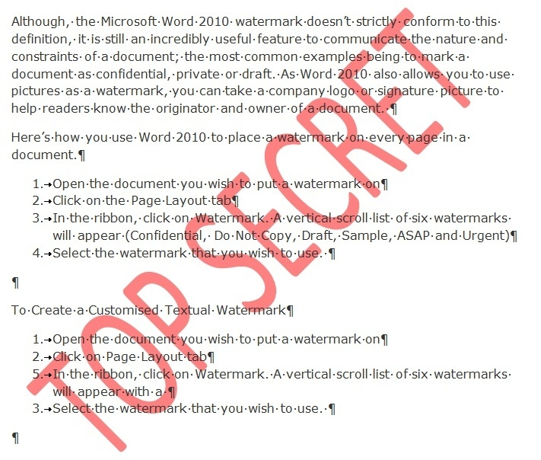
Figure 2: Sample document with watermark

J. Accessibility Checkers
MS Word has an accessibility checker available to help you ensure your files are accessible. The Accessibility Checker can be accessed from the Review tab: Review > Check Accessibility. In Word 365, the checker also runs automatically in the background. The accessibility checker will prompt you through the process of correcting most of the accessibility issues in the document as well as provide instructions. This includes remove repeated blank characters if present. Note: The accessibility checkers are not able to test for color and other considerations that need to be manually tested.

Conclusion
Creating an accessible Word document is readily achievable by following the guidelines above. It is also always a great idea to have a screen reader user test your document for accessibility to ensure that the document if fully accessible.

Due to the accessibility limitations, it is recommended that documents with complex tables be converted to a more accessible format such as HTML or PDF where additional accessibility settings can be made.

Resources:
The following is an excellent resource from Microsoft on Creating Accessible Word documents:
Creating Accessible Word Documents
Writing Accessible Math in Word Documents

