
Making Accessible Slides

Revised: February 2026
Revised: August 2026

Contents

General Considerations 3
A. Styles 3
B. File Metadata (NEW!) 3
C. Alternate Text for Images (UPDATED!) 3
D. Making Links Accessible 5
Windows: 5
Mac: 5
E. Tables 6
Data Cell Formatting: 6
Table Summaries (UPDATED!) 6
Embedded Tables: 6
Complex Tables: 7
Table Headers: 7
Tables with Images: 7
F. Color and Contrast 8
G. Patterned Backgrounds 8
H. Reading Order 9
Setting the Reading Order 9
I. Shapes and Text Boxes 10
J. Animations embedded in PPT 10
K. Math Content (UPDATED!) 11
L. Videos 12
M. Accessibility Checkers 12
Conclusion 12

General Considerations

A. Styles
Slides can be structured with styles to make the layout easier to navigate for users with disabilities. You cannot add headings to slides. However, you can use one of the predefined Slide Layouts from the Home Tab.

B. File Metadata (NEW!)
Metadata can be added in the File menu but selecting Properties. On the second tab of the Properties pop up is the Summary.

An additional piece of required metadata is located in a different section. Under Review > Language, set the document language to English (United States).
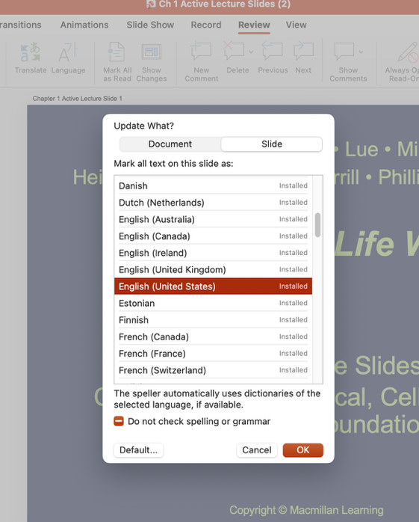

C. Alternate Text for Images (UPDATED!)
All images that convey meaning need to have alternate text applied so the purpose being communicated is conveyed to users of assistive technology. Consider the following when creating alternate text:
- The textual descriptions need to be short and concise while still being meaningful and informative.
- The alternate text should stand alone and act as an equivalent for the image if the image were removed.
- Before writing a description, consider the context in which the image is used: does the text alternative need to convey what the image is, or does it need to convey what its purpose is?
- Alternative text should not use the phrases "an image of…" or "a graphic of…" or “a headshot of” or a “photograph of” etc. Instead be succinct. “Graphic: …”, “Headshot: …”, “Photograph: … “ are preferred.

To add alternate text:
- Select the image.
- Right-click on the image to activate the context menu, or focus on the image and press SHIFT+F10.
- Select “Edit/View Alt Text…”
- In the Alt Text panel that opens, enter appropriate alternate text for the image in the text input.
- If an image is decorative or is described elsewhere on the slide, select the “Mark as decorative” checkbox in the Alt Text pane.

Note on Master Slide Content: Master slide content that conveys meaning must be conveyed to the user in an accessible manner on each slide as well. However, this information is in the background and is not available to screen-reader users. In order to correct this, do one of the following:
- Option 1: Move any information in the Master Slide that conveys meaning to the normal presentation slide.
- Option 2: For logos, copyright information, or revision dates that appear on all slides, ensure that equivalent information is presented in an accessible manner on the first normal presentation slide (it does not need to be repeated on all pages).

D. Making Links Accessible
Providing meaningful link text is important when creating links. The text needs to describe the content behind the link or the action that will occur by activating the link. Generic terms − such as “click here” or “read more” − do not provide adequate information on where the link will lead the user and should be avoided. In addition, “click here” implies users are using a mouse. In slide files, some screen readers will not instruct the user that a link is actionable. As a result, all links should have the URL included or an indication that the link is a link, such as Find Out More About Macmillan Learning (Link).

Link Process: Type the link text, then highlight it. Follow the steps below depending on your operating system.

Windows:
- Right click on the highlighted text to open the context menu.
- Choose Link.
- Enter the URL in the Address input, then press the OK button.

Mac:
- Right click on the highlighted text to open the context menu.
- Choose Hyperlink…
- In the dialog, choose the “Web Page or File” tab and enter the URL into the Address input, then press the OK button.

You can also select the “ScreenTip” button to add text that will appear when users hover a mouse over the link. However, this text is not read by screen readers and cannot be exposed by keyboard-only users.

E. Tables
Note: Accessibility of data tables in slide presentations is limited. If you must use data tables, keep them simple and follow the guidelines in this section. If your presentation makes extensive use of data tables, or if the tables are complex, consider converting the document to a more accessible format, such as HTML or PDF.

Data Cell Formatting:
Data tables should be formatted utilizing built-in table features. Data from multiple rows should not be combined in one row as assistive technology users will be unable to identify what the data is associated with.

Table Summaries (UPDATED!)
Because automated accessibility checkers treat tables, even those that can be navigated by a screenreader, as an object or image, tables require alt text. To add alt text to a table, select the entire table by clicking on the border, the right click to view alt text. From here, provide a summary of the table in the alt text field. Note: If you select just one cell or a group of cells, the view alt text option will not appear.

Embedded Tables:
Embedded tables in a slide presentation are not accessible to users of assistive technology and should be avoided. For example, an embedded Excel file with a table will not be accessible to screen-reader users: only the filename will be read aloud. Rather than embed a table, link to the table in an accessible format instead.

Complex Tables:
Complex tables in slides can be extremely challenging to navigate for screen-reader users. If you have complex tables, consider converting the document to HTML or PDF (or offering a PDF alternative to the slide deck), giving users access to the source files or providing the table on a Web page. (Note: This is especially important in slide documents as the text in a complex or a simple table is simply presented in a linear fashion. Screen-reader users cannot take advantage of table-navigation commands when reading the table in a slide.

Table Headers:
There is no way to set a <TH> (table header) in slides. However, you can set the header row – this will designate all cells in the first row as column-header cells as in an accessible PDF. You can also set the header column, which will designate the cells in the first column as row-header cells. (Note that while most data tables will have a header row, not all will have a header column.) Access this setting by inserting a table and then going to the Table Design ribbon, then checking the box for Header Row. If you have row headers, check the box First Column as well. If you export the slide to PDF, the table will be tagged accessibly.

Tables with Images:
While you can insert an image into a table cell, you cannot add alt text to that image. For this reason, avoid adding images (including images of math) to tables and instead use a different layout that does not require a table at all. If you must add images into cells, however, the entire table should be turned into an image that is marked with descriptive alt text for the whole table – text and images included.

For Math in tables: Take a screenshot of the table with the MathType equations pasted over it. Then, add alt text for the entire screenshotted table image including the equations.

F. Color and Contrast
If color alone is used to convey information, people who are visually impaired or colorblind will not have access to this information. In addition, if insufficient contrast is used, people who cannot differentiate between certain color combinations, or who have some other visual impairment that affects the perception of color, may have difficulty navigating or interpreting content that relies on the ability to identify color contrast differences.

Recommendation: Ensure all foreground/background color patterns meet the WCAG 2.2 Level A and AA guideline, which is a 4.5:1 ratio for standard text and a 3:1 ratio for large text (14 point bold or 18 point or larger). Note: You can test the color contrast of your documents with the free Colour Contrast Analyser (link).

G. Patterned Backgrounds
Avoid using patterned backgrounds and watermarks as these can interfere with the contrast of the documents and obscure text. In addition, the watermarks are not accessible to screen-reader users.


Figure 3: Screenshot of a watermark

H. Reading Order
By default, the reading order of a slide is the order in which objects are added to the slide. This means that users of assistive technology will read the slide in the order text, images, charts, etc. were added to the slide – not the order that is visually indicated in the slide. When reading order is set correctly, people using assistive technology can read the information on a slide in the order in which it is meant to be read. Screen readers may have difficulty identifying complex layouts in the proper sequence if the reading order is not correct, and the meaning and relationship of the content may not be easily understood by users of assistive technology.

Use the Reading Order Pane (or Selection Pane) to visually see and arrange the order of objects on a slide, and to arrange the programmatic reading order to match the visual reading order (top to bottom, left to right, or the order in which the content is intended to be read).

Setting the Reading Order
- Select the Home Tab
- In the Drawing group, select the Arrange button.
- From the menu, choose Selection Pane.
- The reading order in the Selection Pane begins at the bottom and moves to the top: in other words, the first object in the visual reading order will appear at the bottom of the Selection Pane, and the final object will appear at the top. With this in mind, select each item in the Selection Pane and use the up/down Reorder buttons (Windows) or the “Bring Forward”/”Send Backward” buttons (Mac) to move objects to match the visual reading order. Alternatively, drag and drop the elements in the Selection Pane into the correct reading order, from the bottom to the top.
- Verify the reading order by placing your cursor at the top left of the slide and pressing the tab key. The reading order should follow the Tab-focus order as you press the Tab key on the slide.

I. Shapes and Text Boxes
Even though alternate text can be added to Shapes inserted in slides, screen readers can’t access this information. Based on this, the recommendation is that Shapes not be used as the sole means of communicating meaning in presentations. If you want to use text with a Shape, type that text into a text box and then position it over the Shape rather than typing it directly into the Shape. Avoid the use of SmartArt whenever possible.

J. Animations embedded in PPT
When an animation is pedagogically necessary within a slide deck, alt text for the animation can be addressed by adding an ‘Easter egg’ (hidden image) to the slide. Create an empty image that can’t be seen by users but has alt text describing the end goal of the animation (rather than a step by step breakdown of the animation). Alternatively, create a text box that can be seen by users, and provide a summary of the animation that is available to all users. This description can benefit all users. Note: When adding animations, flashing, blinking or continuously playing animations be sure they do not flash more than three times a second in accordance with WCAG 2.3.1. Additionally, avoid auto-playing animations. Instead, give users controls to play and pause animations when they want to.

Similarly, use animated transitions (e.g., fades, slides, fly in/out, wipes, etc.) sparingly or not at all. If transitions are necessary, adjust speeds to reduce motion as much as possible, and avoid effects that could cause disorientation, such as spins, flips, rotations, etc.

K. Math Content (UPDATED!)
Do not use the built-in Equation Editor as this is not accessible to all assistive technology. The current best practice is to enter equations using the MathType toolbar add-in (not MathType 7, the fully licensable tool), which outputs an image.
- You’ll need to manually add alt text to the image: right-click on the image of math, choose View Alt Text… and type the alt text into the panel.
- Alt Text can be automatically generated using a number of tools available outside of PowerPoint, including MathType in Word.

Note that in a slides presentation, MathType expressions and equations are always shown as display objects–that is, they are standalone objects that can be positioned anywhere on a slide. It is not possible to employ MathType equations directly in a sentence or paragraph (also known as inline math).

Finally, if you need to use individual mathematical symbols within a sentence or paragraph, these may be entered using the Symbol dialog found in the Insert ribbon. When using this method, be sure to set the font to Cambria Math.

When updating older documents:
- DO: Check if equations are images
- DO: Budget to convert to images
- DO: Schedule transition to images and document in ACU Jira ticket

L. Videos
Ensure videos have captions and descriptive text transcripts. Also ensure that the video controls are labeled and accessible. It's generally a more accessible practice to link to videos rather than embed them in a slide deck. Additionally, avoid auto-playing video or audio. Instead, give users controls to play and pause these objects when they want to.

M. Accessibility Checkers
Most slide creators have an accessibility checker available to help ensure your file is accessible. To access the accessibility checker, go to the Review tab and select the “Check Accessibility” button. The accessibility checker will prompt you through the process of correcting most of the accessibility issues in the document as well as provide instructions, but depending on the complexity of the slides, there may be obstacles that the checker does not identify. For example, the accessibility checkers can test for some types of low-contrast text, but it may not catch all instances. Foreground/background contrast patterns should always be manually tested.

Conclusion
Creating an accessible slide deck is readily achievable by following the guidelines above. It is always a great idea to test the document with a screen reader, or to ask a screen-reader user to test your document to ensure it is as accessible as possible.

